

SIMATS ENGINEERING

Saveetha Institute of Medical and Technical Sciences
Chennai- 602105

Student Name: DEVADHARSHINI E Reg. No.:192524483
Course Code: ECA 4751 Slot: A
Course Name: PRINCIPLE OF DIGITAL SYSTEM AND DESIGN THINKING FOR MARINE ENGINEERING
Course Faculty: DR. JUDY SIMON DR. AROCKIA JAYADAS
Project Title: SOIL MONITORING SENSOR USING ARDUINO
Module Photographs: (3 photographs –Module Photo, Individual student contribution module work in the project and presentation image)
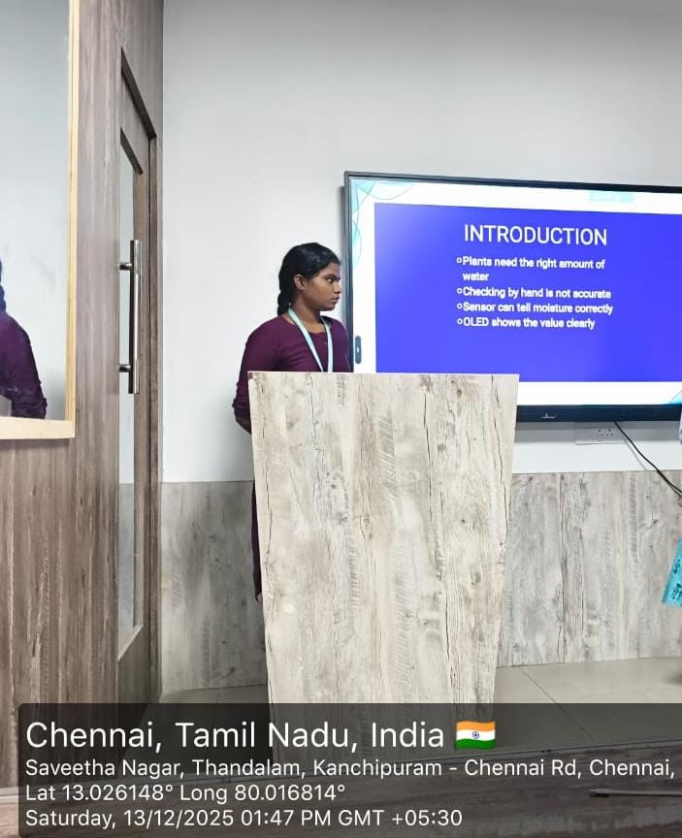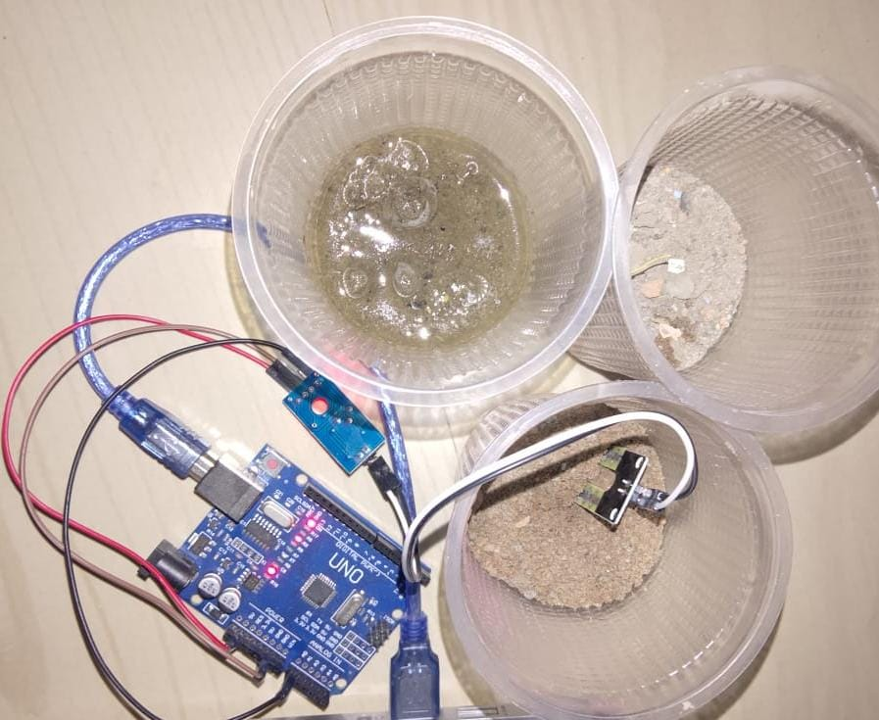
Project Description: (here you write what you did in this project (contribution) including Model Description
This project “Soil Moisture Monitoring Using Arduino” helps farmers monitor soil water content accurately.
It classifies soil condition into Dry, Normal, and Wet, enabling better irrigation decisions.
The system reduces water wastage and improves crop productivity.
It is a low-cost and easy-to-use solution for modern agriculture.
The project supports sustainable farming and environmental conservation.
It provides a strong base for future improvements like automatic irrigation and smart farming.
Overall, the project successfully bridges traditional farming with modern technology.

Student Signature Guide Signature

